1. 
2. In earlier lecture, we created **3-Node Kafka Cluste**r and in this lecture, we’re going to use it and doing the following things.
   1. Diagram

      Description automatically generated with medium confidence
      1. We will create a new **Kafka Topic**.
      2. Then will make sure that we have **three partitions**.
      3. Then we will start **two Consumers** in the same **group (Consumer Group Cluster)**.  
         Both of these **Consumers** will be reading data from the same **Topic**.  
         As they are running in the same **Consumer Group**, so they should share **workload**.
      4. Finally, we will start the **kafka-console-producer.bat** & send the **CSV File** to the **Kafka Cluster.**We will come back to the **Consumer Group** and observe the outputs.



1. First, make sure your **3-node Kafka Cluster** is running state.
2. Let’s create a new **Topic**.  
   
3. 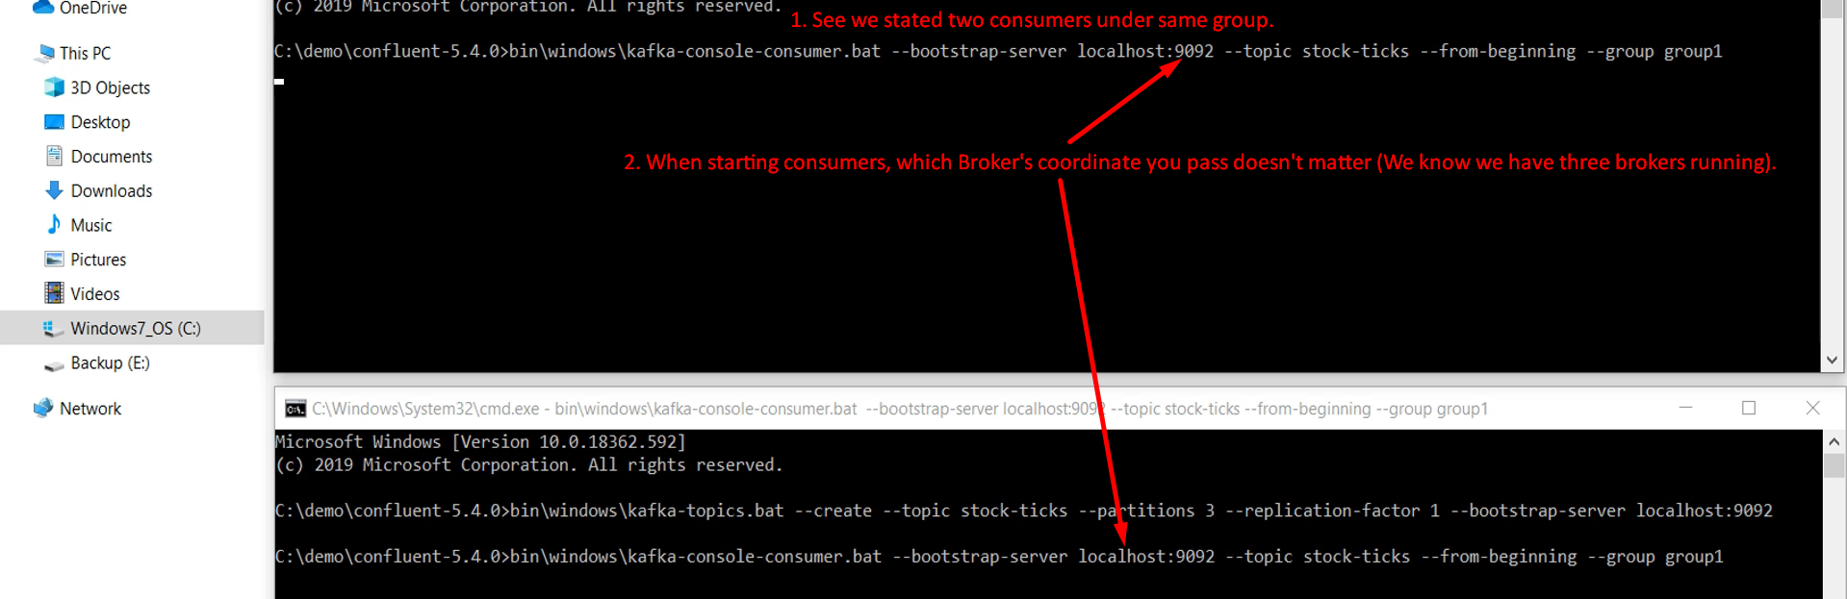
4. Graphical user interface

   Description automatically generated
   1. **Question**: Why just one broker needs to be specified when starting a consumer even though we have 3 brokers?
   2. **Answer**: Connecting a consumer with one broker will connect the consumer with the entire Kafka Cluster (Set of Brokers).
5. Let’s start a producer sending one data file.   
   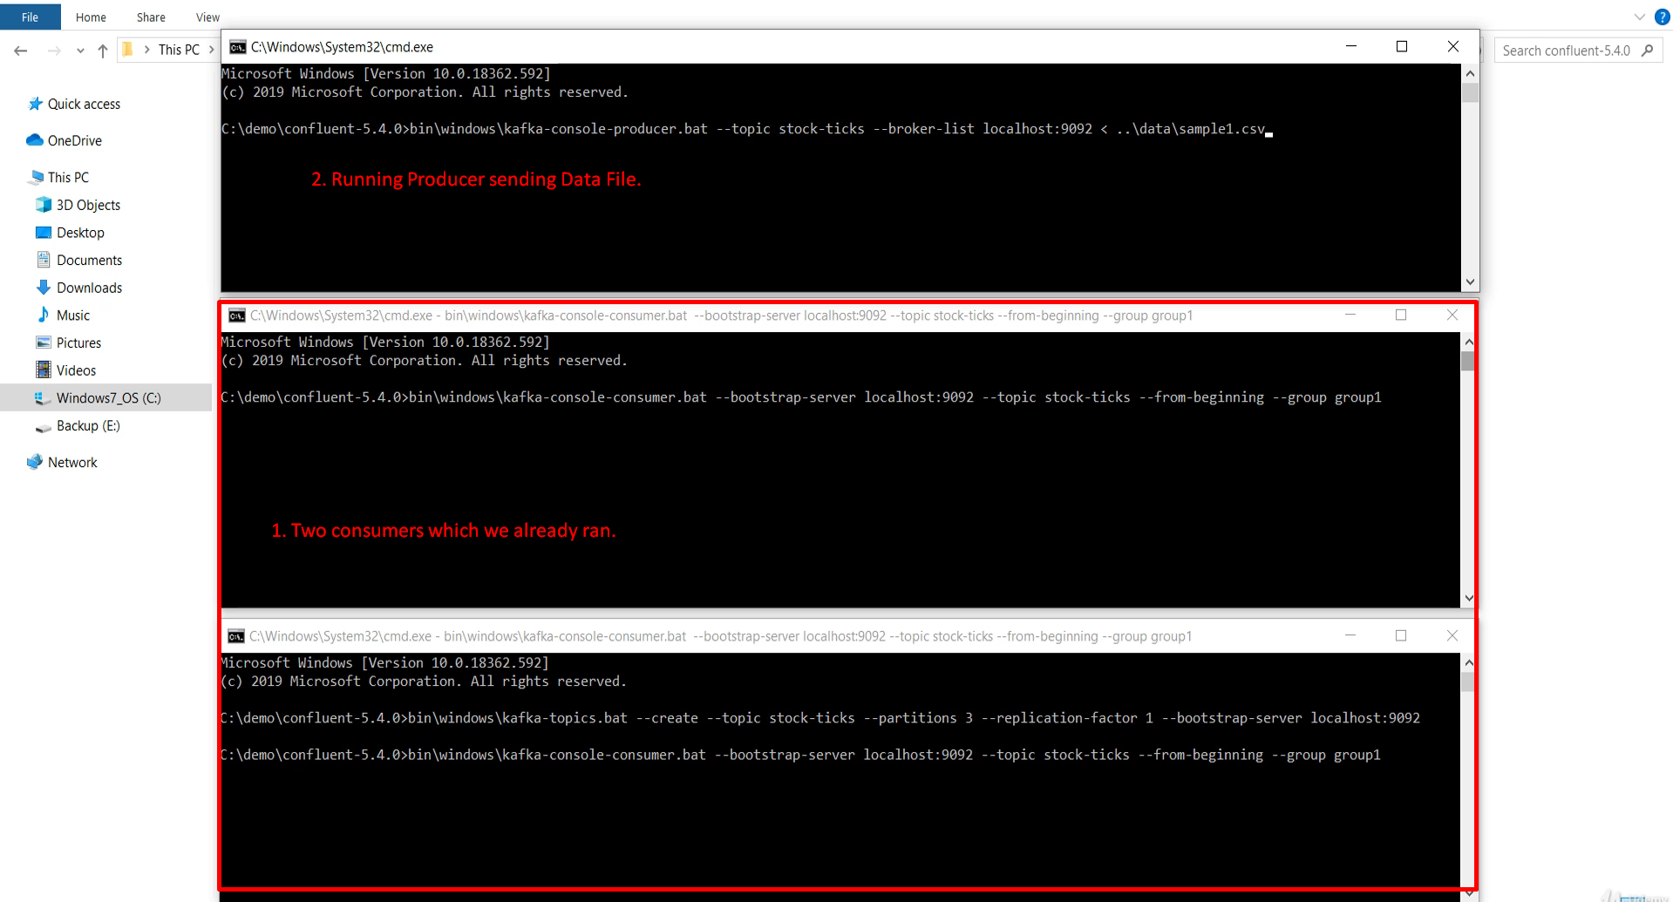  
   Make sure that producer is pushing the msgs into the same topic from which the two consumers are reading.  
     
   Diagram

   Description automatically generated
6. Text

   Description automatically generated with medium confidence
   1. But how do we know how this all happened?
   2. Let me show you.
   3. 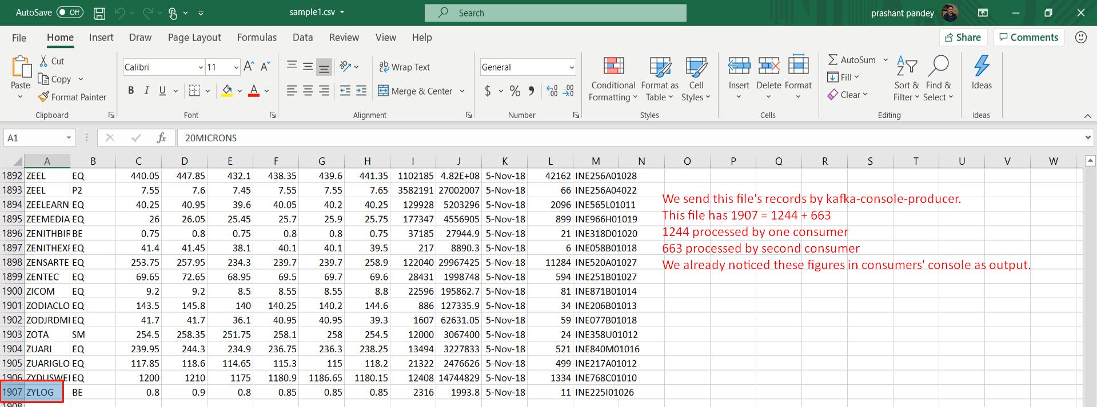
   4. Let’s figure out how many records each partition received.   
      Till now we saw from the consumer console output that one console processed 1244 records and another console 663 records.   
      With this knowledge let’s see how many records each partition received.   
      Let’s go to the log directory for each Broker.   
      A picture containing chart

      Description automatically generated  
        
      Graphical user interface, application

      Description automatically generated
   5. 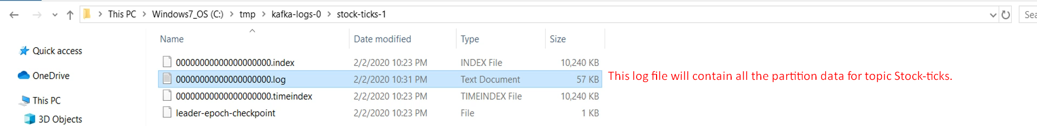
   6. Graphical user interface, text, application

      Description automatically generatedSimilarly, we can dump other’s partitions’ log file.   
      Graphical user interface, text

      Description automatically generated  
      Let’s summarize with Diagram.  
      Diagram

      Description automatically generated
7. **NOTE**: We can use kafka-dump-log.bat to dump records in the partitions.
8. So, what we learnt in this lecture.
   1. Kafka Cluster will store data in the topic partitions.
   2. Each partition is managed by a separate broker as a storage dir.
   3. But the actual data sit in a log file in that dir.
   4. We can use **kafka-dump-log.bat** to investigate these log files.
   5. Consumers can work in consumer group to share workload
9. The main purpose of this demo was to give you insight of how partitions and consumer group work.